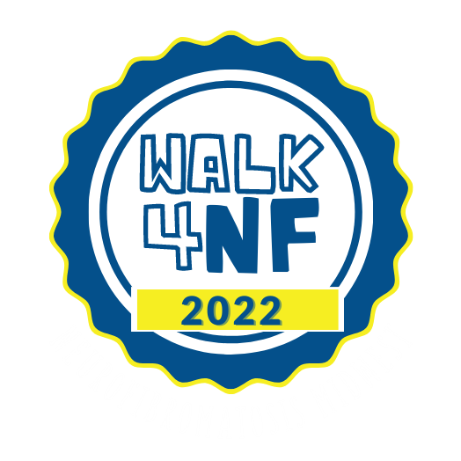
Sample of a fundraising appeal letter you can share on social media, email or use for regular mail. See further instructions on reverse.
Dear Family and Friends:
Thank you for all your love, support and prayers over the last few months. We are writing you to ask for your support for the neurofibromatosis cause. As you may know our daughter Jane was diagnosed with neurofibromatosis type 1 or NF1 this past January.
Her doctors found what they consider a low-grade brain tumor on her optic nerve as a result of this disorder. Jane has been undergoing chemotherapy treatment and will continue over the course of the year in hopes to stabilize the tumor’s growth to keep her eyesight intact. She also undergoes MRIs every three months to note the progression of the tumor. She is a true inspiration and shows such bravery and strength at such a young age!
Neurofibromatosis is set of genetic disorders of the nervous system that causes the growth of tumors to form on nerves anywhere in the body. NF affects 1 in 2,500 people worldwide. It can cause many other symptoms and affects each person differently. Currently there is no cure for this disorder.
As everyone with NF does, we are learning to live day to day. We are hoping for a future that will bring us new opportunities for treatment and eventually a cure for this disorder. This is where you, our family and friends come in. You play an important role in helping us to get that much closer to this goal.
In honor of Jane, we have formed a team called, “Join for Jane.” We will be honoring her by walking for a cure and to improve care on [DATE] at the [LOCATION].
NF Midwest is the local regional non-profit that C.A.R.E.S. to help improve the lives of people with NF. By donating to my page, YOU are helping in this mission.
C- improve clinics
A- raise awareness
R- fund research
E- increase education
S- offer support
Thank you so much for your generosity and helping us “Join for Jane” to raise NF awareness in hopes of finding a cure! Please remember that no gift/donation is too small! Feel free to forward this on to anyone who may wish to donate to the cause as well! Thank you from the bottom of our hearts.
With heartfelt gratitude,
Your Name

Fundraising is easier this year than ever before…..

- The easiest way to fundraise is to utilize all of the online fundraising tools available to you now that you’ve registered for the walk. When you registered you should have received an email with a link to your Great Steps fundraising page. It’s best to personalize the template we provided. You can upload your own pictures of you and your loved ones too. Then you can send a fundraising email, share on Facebook, Twitter and more. Go to www.nfmidwest.rallybound.org and log in to your personal “My HQ” (Rallybound headquarters page) for everything you need to get going. It’s never too early to fundraise and your family and friends want to help.

- For your friends and family who are less tech savvy and still like a letter in the regular mail, use the sample letter, or create your own story. Send your letter with a donor form and a return envelope. Still include the link to your page though because they can easily donate online using their credit card, if they prefer.

- If you want to send an email to your contact list outside of the Rallybound fundraising system, be sure to include the link to your fundraising page. It’s just so easy for your friends and family to donate online, and they can save a stamp!!

- No matter how you fundraise, don’t forget to ask if they want to donate a basket for our raffle or become a Great Steps Walk 4NF Sponsor. There are many sponsorship levels and you never know who has important business contacts. You never know who knows who, just ask!

Call the office at 630-945-3562 or email events@nfmidwest.org if you have any questions or need other ideas.

Thanks to you, no one with NF fights alone!

The NF Midwest Great Steps Walk 4NF Committee

