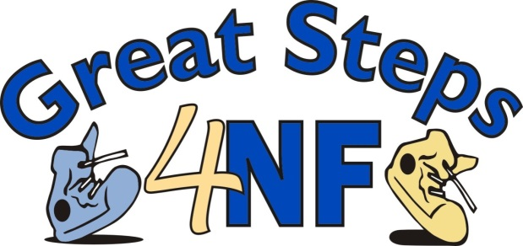

Dear [Name]:

[My child/One of my loved ones] has neurofibromatosis, or NF and I am looking for hope in the form of help from your organization.

Neurofibromatosis can cause tumors to grow on the nerves on the inside or outside of the body anywhere and at any time. These tumors can cause damage due to the space they take up. They can erode organs and bones, causing pain, hearing loss, blindness, loss of limb,
disfigurement and partial or full paralysis, among a host of other difficulties. These tumors may occasionally turn cancerous. On top of this, NF also causes a high incidence of learning
disabilities and can also cause seizures, bone abnormalities, short stature, scoliosis, headaches, high blood pressure, poor fine and gross motor coordination, precocious puberty...the list goes on and seems to grow longer all the time.

I am determined to help my [child/loved one] and the hundreds of thousands of others suffering from this cruel disorder. Since it affects approximately 1 in 2,500 - more than muscular
dystrophy, cystic fibrosis, and Tay-Sachs combined - and causes so many different problems,
I know that not only will our efforts help my [child/loved one] and those affected, but research into this disorder will spill over into and solve the mystery of many other disorders.

As an active member of the neurofibromatosis community, I am on the committee for this year’s Great Steps 4NF Walk that is being held at the Naperville Riverwalk in Naperville, IL on June 2 and I am looking for sponsors, in-kind donations and raffle prizes. Your generosity will be duly noted and appreciated.

Because NF Midwest is a 501(c) 3 non-profit organization (FEIN 22-2580173), your contribution is tax deductible as allowed by law. Together we will strive to raise the level of education about NF and someday find the cure. Thank you for your consideration and generosity.

See the attached sheet for more information. Please contact me or NF Midwest if you have any questions.

Sincerely,

[NAME]
[ADDRESS]
[PHONE/EMAIL]

P.S. Thank you for taking the time to read this letter and consider our request.
For more information please contact Neurofibromatosis Midwest at:
473 Dunham Rd, Suite 3
St. Charles, IL 60174
630-945-3562
info@nfmidwest.org
www.nfmidwest.org
